A Project Report On

A BLOOD DONATION MANAGEMENT SYSTEM WEBSITE

Submitted by:

Ashutosh Kumar (49)

Mebanseibor Lyngdoh (56)

First Year Undergraduates in B.Tech Computer Science Engineering

*LPU, Punjab (India)*

Academic Year: 2022-2023**Acknowledgement**

*Before we introduce our project to the world, we would like to take a moment to thank our professor, Dr. Mohammad Faiz, for giving us a chance to present our skills and strengths in this project and also for being a good mentor and guiding light in our path to create this project. He encouraged us to think outside the box and to not give up but to have perseverance to continue on even when the task seems daunting. With his extreme expertise in this field Web Development, we were able to make this website that would surely aid humanity in the coming years.*

*I would also want to show my gratitude and appreciation towards our university, Lovely Professional University, for giving us the chance to work on this project.*

**BLOOD BANK**

A Blood Donation Management System Website

**Abstract**

Blood donation is a vital part of worldwide healthcare. It relates to blood transfusion as a life-sustaining and life-saving procedure as well as a form of therapeutic phlebotomy as a primary medical intervention. Over one hundred million units of blood are donated each year throughout the world. [1] This article will concisely discuss a brief history of blood donation origin and purpose, blood testing, donor eligibility and selection, adverse effects of donation, blood donation as a primary medical intervention, and a short discussion of pathogen reduction and inactivation for donated blood. It will also discuss the digital aspect of allow donors to support this cause by registering and being informed about the various blood donation mission through the features of the proposed Blood donation website.

**Introduction**

Before we start introducing our website, we will first answer the question “What is Blood?” Blood is the most significant gift of life that a person can give to others. [1] Donated blood is always lifesaving and valuable for people who have lost a significant amount of blood due to various reasons like serious injuries, surgical procedures, medical conditions etc. Therefore, all time availability of blood in blood banks has become a prime concern for the society. [2]

**Medical Terms**

* Haemoglobin (Hb): It is a body protein that contains iron and provides red colour to blood. It also carries oxygen from lungs and nourishes all body tissues.
* Iron: It is a part of Hb that helps in synthesis of red blood cells and replaces the lost ones.[3]
* Antigen:It is a molecule of protein that is found on the red blood cell (RBC) surface.
* Antibody:It is a plasma protein that acts as a natural defence of body. It warns immune system to destroy foreign substances like germs.
* Rhesus (Rh) factor:It is an antigen that may or may not be present on the surface of RBCs in blood. If Rh factor is present, then the blood type is termed as Rh positive and if it is absent then the blood type is termed as Rh negative.

**About Blood**

**The need for blood:**

As blood is vital for the proper functioning of the human body, therefore, anybody who has low blood levels (1.2-1.5 gallons of blood) would face serious life threatening issues and organ failure. As blood can be stored for shorter period of duration, there is a constant need of blood donation to have an adequate and safe supply of all blood groups in time of need. Each donor contributes significantly to meet the challenge of accessibility and affordability to patients by making it available whenever and wherever wanted.

Not only it helps saving lives, but also plays a vital role in improving health of a donor.

Blood should be accepted only from voluntary, non-remunerated, low risk, safe and healthy donors. Replacement of donors should be phased out. [6]

**Blood groups:**

* Each person has an ABO blood type (either A, B, AB, or O) which means antigen A, antigen B, both antigens (i.e. type AB), or neither antigen (type O) is found on their blood cells.
* Each person also is either Rh-positive (Rh+) or Rh-negative. (Rh-)

*These 2 factors can be combined to produce 8 possible blood types*:

|  |  |  |
| --- | --- | --- |
| **Blood Type** | **Variant** | **Variant** |
| **A** | **A+** | **A-** |
| **B** | **B+** | **B-** |
| **AB** | **AB+** | **AB-** |
| **O** | **O+** | **O-** |

The ABO group system is determined by the type of antigens (A antigen, B antigen, both A and B antigens and no antigens) and antibodies (anti A, anti B, anti A and B and no antibody) present in blood.

* A blood group has antigen A on RBCs and anti-B antibody in plasma.
* B blood group has antigen B and anti-A antibody in plasma.
* AB blood group has both antigens A & B and no antibody in plasma.
* O blood group has no antigen and both anti- A & anti-B antibodies in plasma.

The Rh factor determines the blood type as positive (+) or negative (-)

**Blood compatibility:**

Blood group A can be given to A and O only.

Blood group B can be given to B and O only.

Blood group AB can be given to AB and O only.

Blood group O can be given to any blood type, specifically, O negative (O-) can be given to anybody as there is no antigen present on its cell surface.

**Rh factor:**

To a person with Rh-positive blood, Rh-positive or Rh-negative blood can be given. But people with Rh-negative blood should only get Rh-negative blood.

During pregnancy, problems can occur if a pregnant woman is Rh negative and her foetus is Rh positive. It is called Rh incompatibility. [8]

**Fact check:**

* Adequate supply of safe blood can only be achieved through regular, voluntary, unpaid donors. [7]
* All donated blood should be screened for HIV, hepatitis B and C & syphilis. [7]
* A single unit of blood can benefit several patients. [7]
* O negative (O-) blood is universally accepted and can be given to any other blood type.
* Red blood cells can be used within 42 days of storage.
* Platelets must be used within 5 days of storage. [4]

**Eligibility to be a Donor:**[6]

* Healthy volunteers of age group between 18-65 years of age, weight at least 45 kg and Hb of at least 12.5 grams can donate blood.
* Healthy males can donate blood once in three months and women once in four months.
* A donor shall not do any type of donation within 12 months after a bone marrow harvest and within 6 months after a peripheral stem cell harvest.
* Pregnant women or recently delivered mother should be deferred for 12 months after delivery.
* People with HIV/AIDS, syphilis and hepatitis, and injected with drugs at any point of life, must never give blood.

**Before blood donation:**

* Make sure your Hb in within normal range.
* Eat iron-rich diet like beans, spinach, fish, red meat and iron-fortified cereals.
* Have a sound sleep and drink lots of fluids.
* No alcohol should be consumed before the donation day.
* Stop taking blood thinning medication before 2-3 days, if any.

**Day of blood donation:**

* Drink extra water or non-alcoholic drink before donation.
* Avoid fatty food like fries, burger etc.
* Wear a shirt with loose sleeves that can be rolled up the elbows easily.
* Take all prescriptions or medications with you, if any.
* Bring a photo identity proof.
* Talk to other donors or staff and relax.

**After blood donation:**

* Keep bandage on the area of prick for next several hours.
* Keep sitting for few minutes after donating blood.
* Eat refreshment given by the staff, you have earned it.
* Do not do any strenuous exercise like weight lifting for the rest of the day.
* If the site bleeds, apply pressure and raise arm for few minutes until bleeding stops.
* In case of dizziness, lie down until you feel better.
* Keep taking iron-rich diet to replace the lost iron store from body. [5]

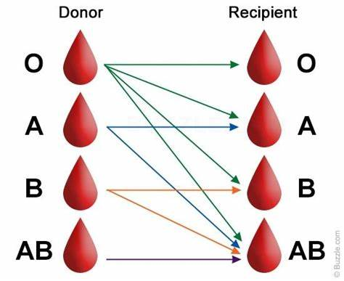

*Picture: Donor and Recipient blood group relation*

##### **Related Work**

Blood donation is an area in which very few people contribute but as we know blood donation is required during an organ transplant, accidents, cancer treatment etc. For blood donation, one needs to check for a donation camp or needs to visit blood bank. The Manual Blood donation system has many disadvantages which includes, it is too time consuming, often leads to error prone results, consumes lot of manpower, lacks donor information, retrieval of data takes a lot of time, percentage of accuracy is less. In the time of emergency, it becomes difficult to approach the right donor. Rare blood groups are not available all the time at all blood banks and recipients find difficulties to track the right blood donor. To overcome this problem, Nevon Projects has proposed a system. There are many blood donation management systems, but these systems only maintain the information of blood banks and donors. But Nevon projects has proposed a system which not only maintains the information of blood banks, but also maintains information of blood camps which makes blood transfusion process easier. This online blood donation management system maintains the list of blood donors and also helps the recipients to track and search the right donor easily. It has two modules namely Admin and User. Admins can add hospitals having blood banks and can also add various blood donation camps. He or she can also view the list of donors available in a particular area with proper Blood cross match. He or she can also check for blood requests and in case of emergency he/she can send notifications to blood donors as per the requirements. Users can register and make a request. Users can also register as a donor. Donors can check for Blood camps and hospitals for blood donation and will be getting notifications in case of emergency. They can either accept or ignore it. This project aims at maintaining all information regarding blood donors, different blood groups available in blood banks as wells as blood camps and help them manage in a better way.

Some of websites provide features to manage the blood management like:

* **American Red Cross:**
  + The American Red Cross Organisation which is also known as the American National Red Cross organisation is a non-profit organisation that aims to help humanity during natural and non-natural disasters. They have a blood donation website that is simple and user friendly.

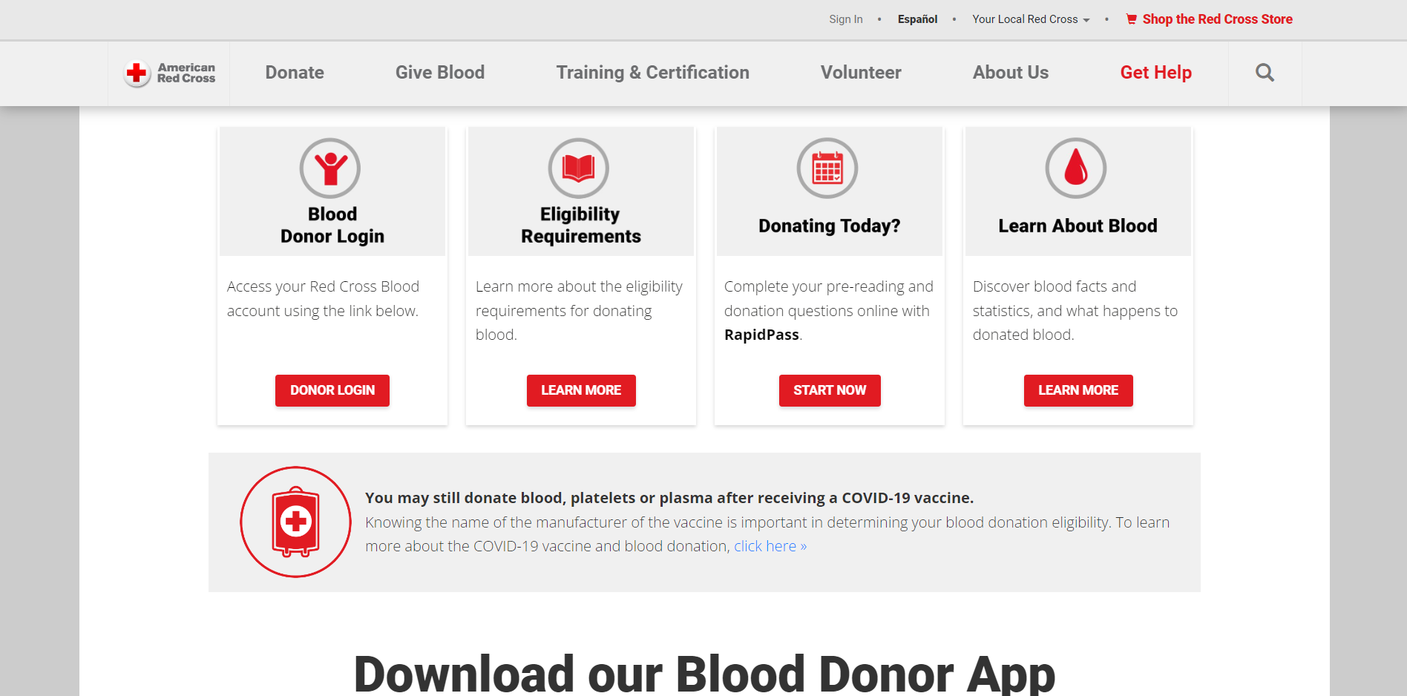

*Picture: American Red Cross Blood Donation Website*

* **E-RaktKosh:**
  + It is an initiative in India that aims to bind and digitalized the blood banks of the nation.

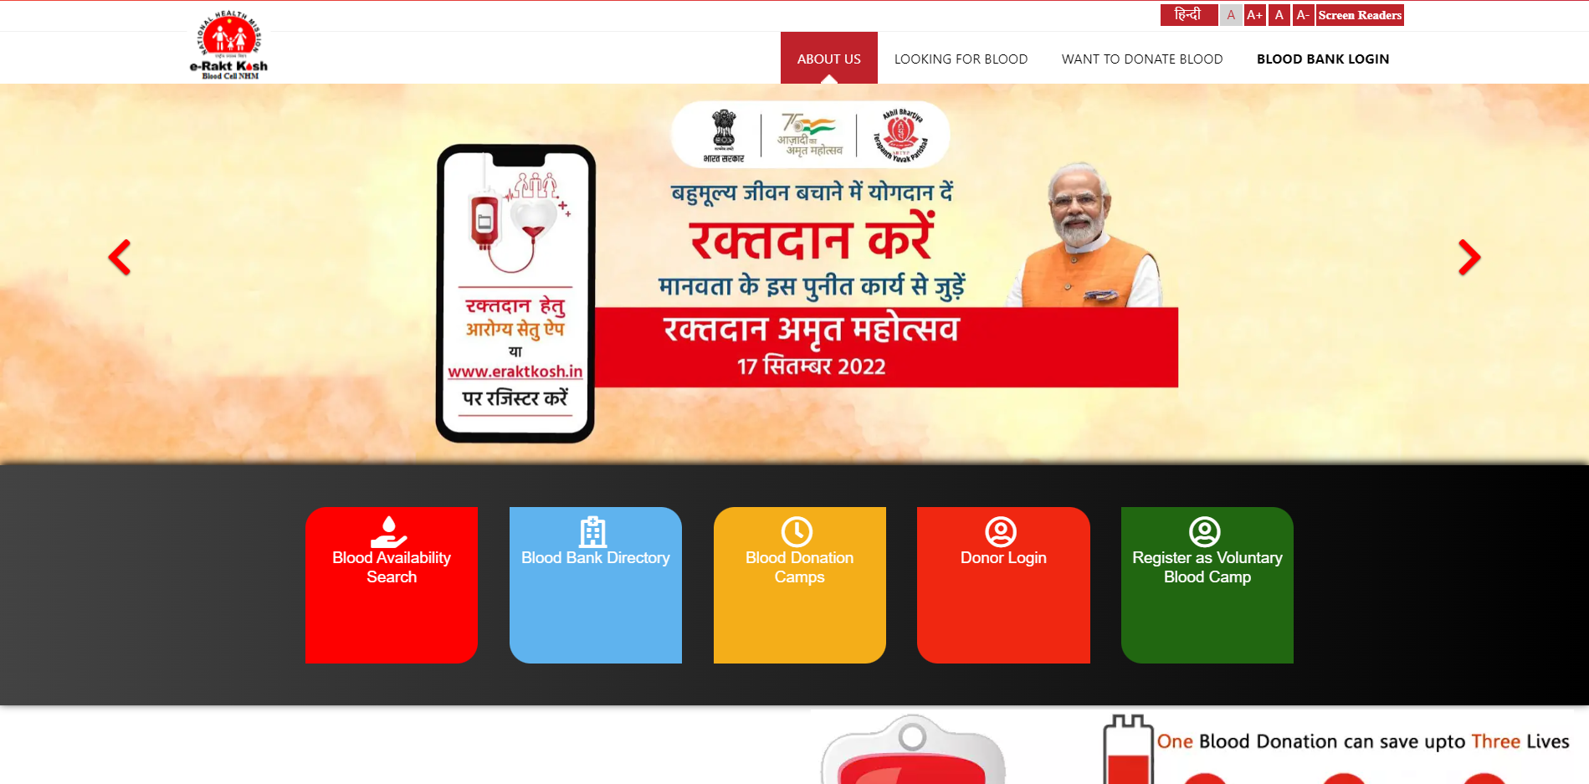

*Picture: E-Raktkosh Blood Bank website*

* **National Service Scheme (NSS):**
  + The NSS or National Service Scheme (NSS) is a scheme based in India which aims to direct the youth to perform and contribute to the community through varies ways to help the society even during a humanitarian crisis.

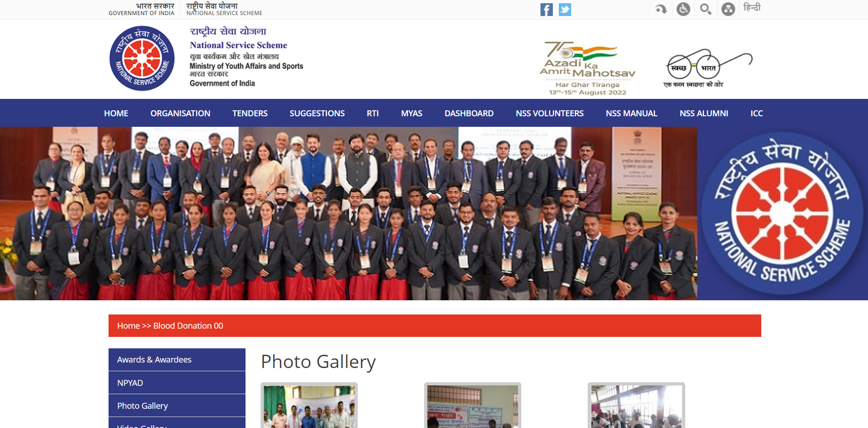

*Picture: National Service Scheme (NSS) Blood Donation Website*

* **NHS Blood Donation:**
  + The NHS or National Health Service is an England based health system funded by the public and is one of the only 4 National Health Systems present in the United Kingdom. It aims to provide healthcare and medical needs to the public which also includes running blood donation campaigns to supply blood to the patients who needs it

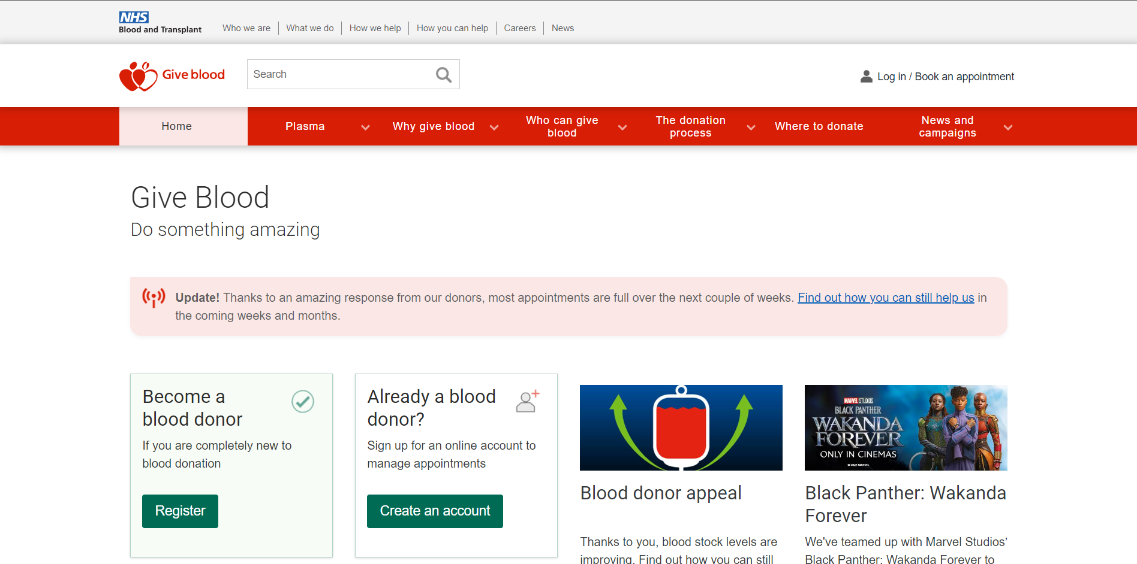

*Picture: NHS Blood Donation Website*

**The disadvantages or the Achilles heel of these websites:**

The major disadvantage of the afore mentioned websites is that the websites are not properly maintain it also fails in many aspects which includes effective ‘advertising’ their mission to the general public etc., despite having a website that is well built. In view of this, we created our website that informs the people of the mission and of the various campaign that are bring help so that we can save more lives.

**Novelty of the Proposed Model**

In our modern world, India is titled to have the second largest population following China. In this situation it is quite difficult to get Blood in emergency. Due to this every day around 12000 people in India die. INDIA collects around 11 million units of blood per year and needs around 15 million which is why too short demand. So to full fill this demand we created this website in hope to save many more lives.

**The Strengths and Limitation of Proposed work**

No matter how many hours we dedicate

**Advantages:**

* Recipients can get blood easily.
* In case of emergency, if the blood group is rare, he/she can find for the certain blood group donor.
* Donors can also donate blood easily by checking the list of blood donation camps.

**Disadvantages:**

* It requires active internet connection.

**Proposed Work**

The proposed work (Beta version) allows many users to easily donate blood. The donor can register in our programme and the data of that user is protected and there is no violation of their Privacy. This helps many people to feel safe and gives them a chance to help the community as any donor that donates blood helps the world in one way or another. The Website also informs the user on Blood and the importance of Blood donation as they browse through the website. Another feature that we added in this website is that we added “LPU-NSS” links which is the National Service Scheme in LPU which allows you to view and get inform of the various blood donation campaign that are being held by their organisation. Focusing on the User-Friendly side of things, we created accessibility features that allows the user to easily contact us for help and for enquiries through our contact details, and through an email enquiry box. Registered users can also be inform of when a blood camp is being help, of our latest achievements in helping humanity. The Website also mentions the various blood centres that are available. The Website was with the idea of creating a user friendly website that is both informative and effective.

**Flow Chart:**

Flow Chart is a Graphical representation of the flow of command and functions of a particular program or Website.

The following diagram is the flowchart for the Website:

Home Page

Is the Login Key pressed?

No

Yes

Direct to Log-in Page

Yes

Login Submit Button is pressed

Is the Inputted data valid?

Alert the user to the errors found

No Yes

**Result**

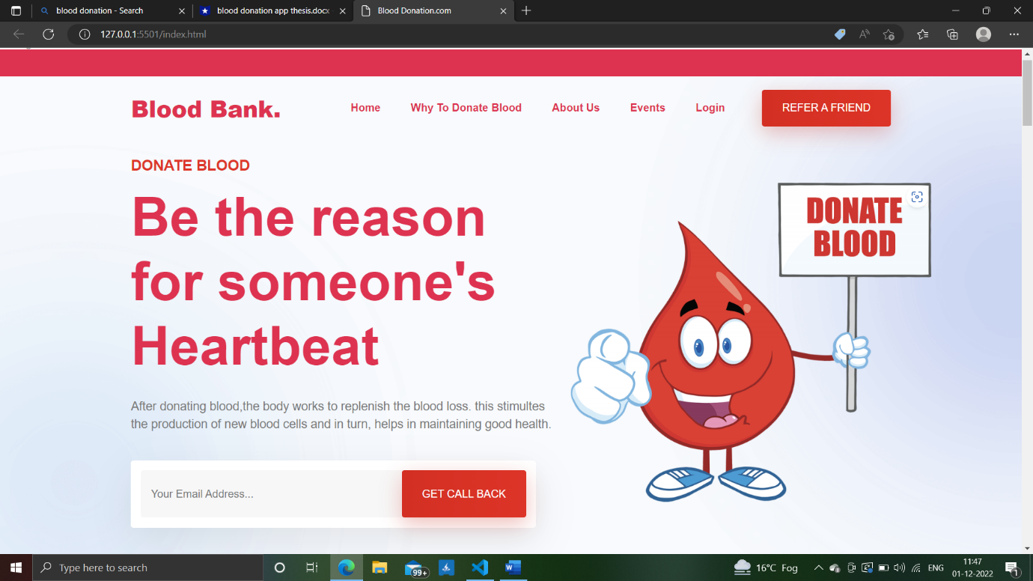

*Picture: Website Home Page*

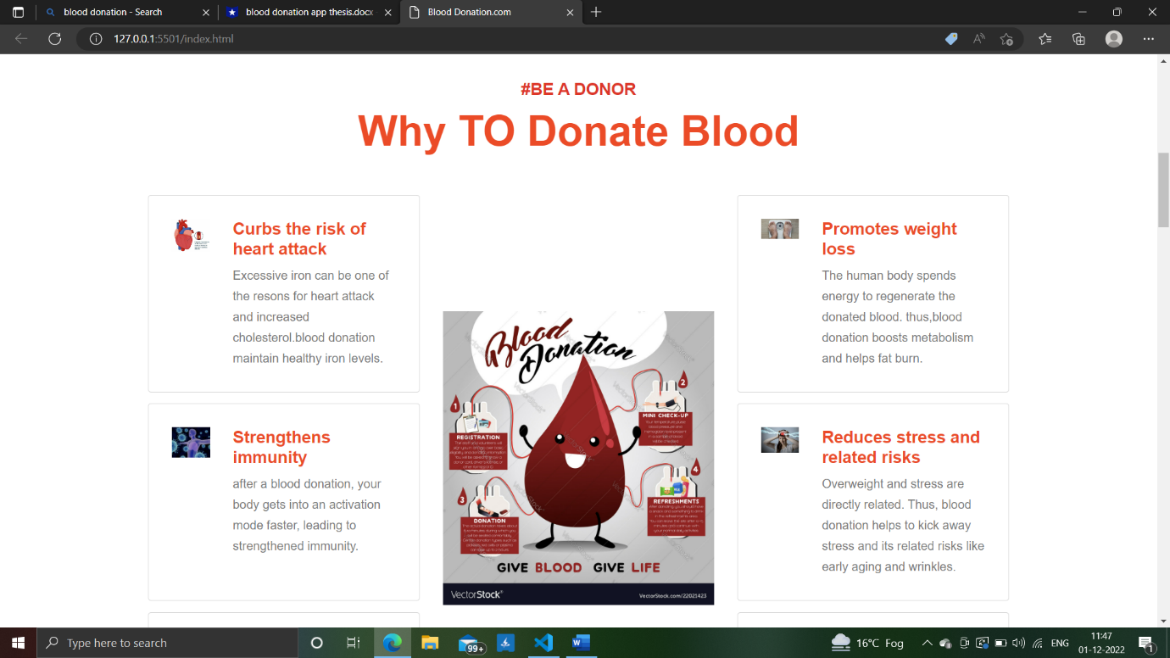

*Picture: Why to Donate Blood Section*

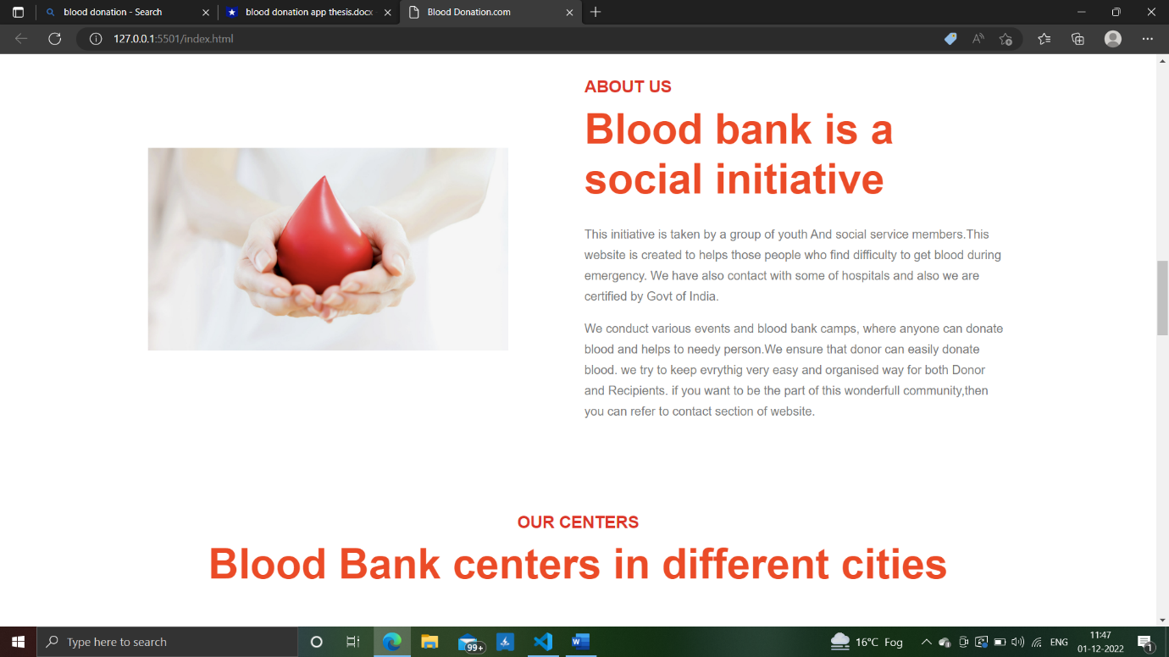

*Picture: About us Section*

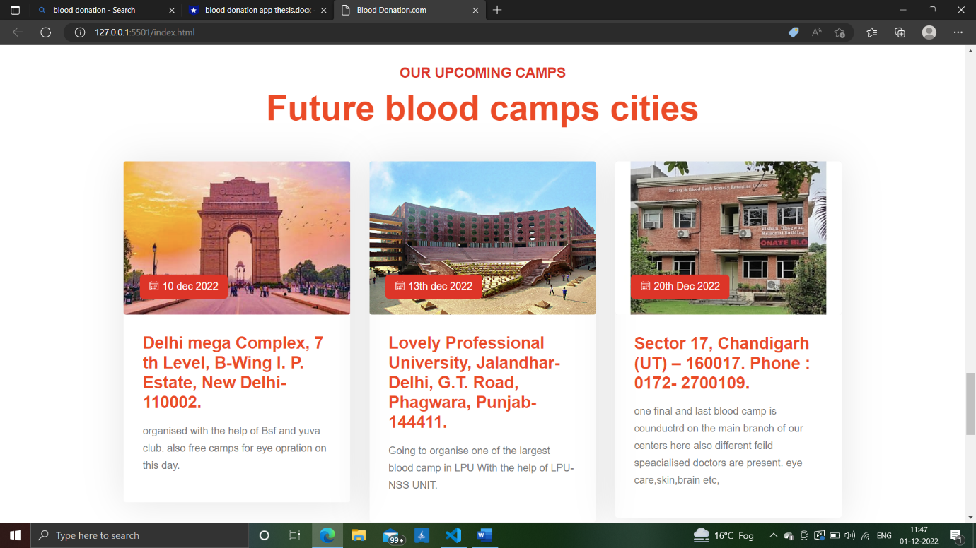

*Picture: Event Section*

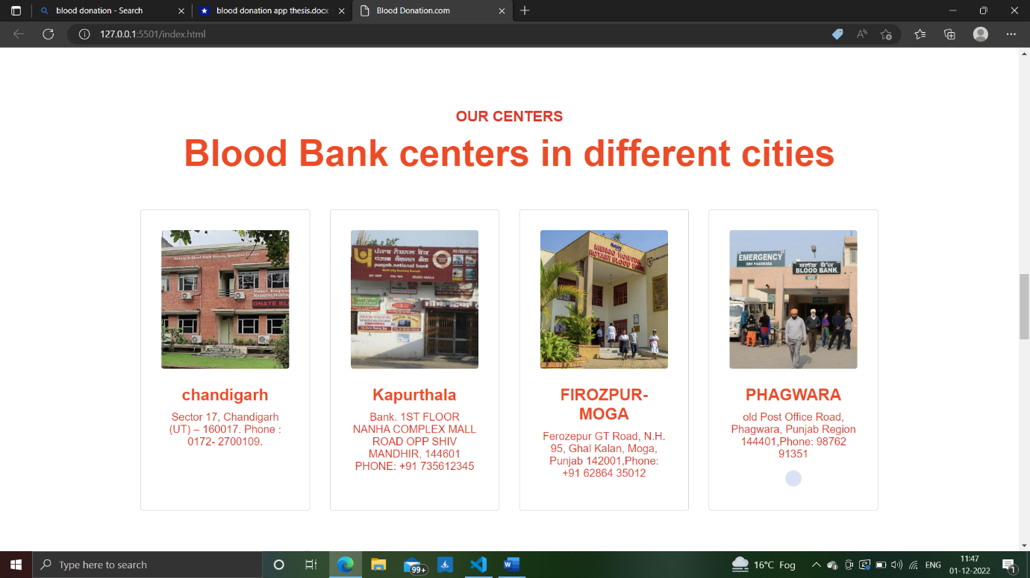

*Picture: Blood Banks Center’s Location Section*

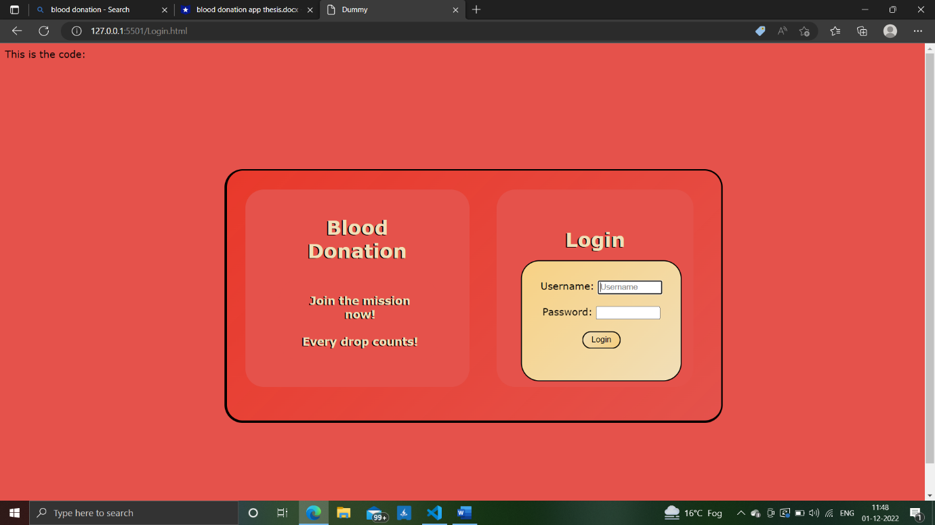

*Picture: Log-in Page*

**Future Work**

The failure to raise awareness among people living in rural areas, and the failure to find a solution to this problem are both significant drawbacks to this digital project. Even after so much efforts, only few people of Indian are able to get blood on time and emergency; the main reason of this that people are not aware that they can easily get blood online for that purpose we want to take help of the NSS Team because as we know that the NSS is a social service community that aim sto help the community in health related problems, we can seek their help to reach the people in need and spread awareness among the public. So in future we want to implement and integrate the NSS team and their principles into our website. In the near future, we may link their website to our website we can reach out to more people. We also want to add some more features to help the NSS and other organisation that shares our mission to help the public.

We also want use future technology, languages and features into our website to further spread our mission. As of now we are currently limited to using HTML, CSS and JAVASCRIPT.

**Conclusion**

As the world move on beyond leaps and bounds in the field of technological and medical innovations, we shall also march alongside to use its in to fulfil our mission to eradicate the shortage of blood and blood banks in both urban and rural areas and to keep the public inform of the various campaigns that are being held near them

**References**

1. <https://www.who.int/features/qa/61/en/>
2. <https://www.ncbi.nlm.nih.gov/pmc/articles/PMC4238271/>
3. <https://www.redcrossblood.org/donate-blood/blood-donation-process/before-during-after/iron-blood-donation/iron-informationforallblooddonors.html>
4. <https://www.redcrossblood.org/donate-blood/how-to-donate/how-blood-donations-help/blood-needs-blood-supply.html>
5. <https://www.redcrossblood.org/donate-blood/blood-donation-process/before-during-after.html>
6. <http://naco.gov.in/sites/default/files/Letter%20reg.%20%20guidelines%20for%20blood%20donor%20selection%20%26%20referral%20-2017.pdf>
7. <https://www.who.int/features/factfiles/blood_transfusion/en/>
8. <https://www.acog.org/Patients/FAQs/The-Rh-Factor-How-It-Can-Affect-Your-Pregnancy?IsMobileSet=false>